

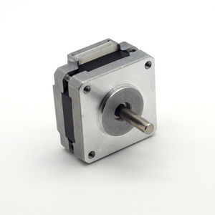

#### 39mm Hybrid Stepper Series

**SPECIFICATIONS:**

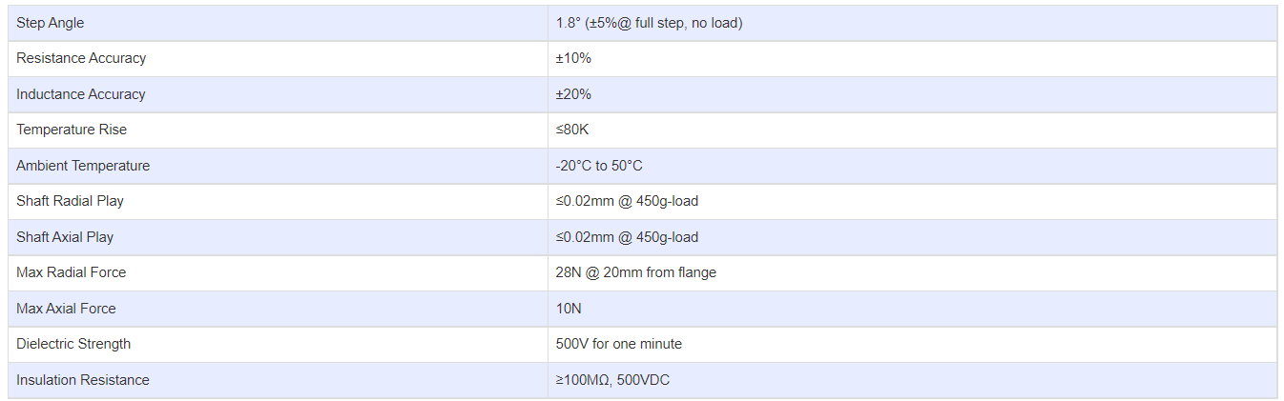

**SUBMODELS:**

*The following are common submodels for the LDO-39STH series.*

